Demo programs and more for Session 34 Delphi Boot Camp 2022

<www.educational-computing.com/CS/Book/DelphiBootCamp2022>

Just add / and the name of the zip file to download a specific demo program. These will be on GitHub but I haven't managed to do this yet.

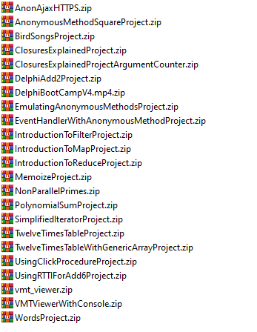

Kevin Bond, August 15th 2022